Reading List 31
DEATH, GRIEF AND LOSS
through Fiction
for Students in Years 10-12
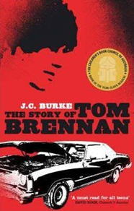
The Story of Tom Brennan by J. C. Burke, 2005
For 17-year-old Tom, life is about rugby, his mates and his family, who are all well-respected in their small country town. But a night of celebration changes his life forever. His brother is involved in a car accident, which kills two people and injures another. His brother is sent to jail and Tom is left to deal with the fallout at school as well as the grief of the affected families.
Hunger Games by Suzanne Collins, 2008
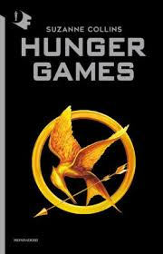
In the ruins of a place once known as North America lies the nation of Panem, a shining Capitol surrounded by twelve outlying districts. The Capitol is harsh and cruel and keeps the districts in line by forcing them all to send one boy and one girl between the ages of twelve and eighteen to participate in the annual Hunger Games, a fight to the death on live TV. Sixteen-year-old Katniss Everdeen, whose father has died and who lives alone with her mother and younger sister, regards it as a death sentence when she is forced to represent her district in the Games. But Katniss has been close to dead before - and survival, for her, is second nature. Without really meaning to, she becomes a contender. But if she is to win, she will have to start making choices that weigh survival against humanity, loss against grief and life against love. The first of a three-part series.
Sequels are Catching Fire and Mockingjay.

After the First Death by Robert Cormier, 1979
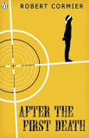
They've taken the children. And the son of a general. But that isn't enough. Who will be the next to die? More horrors must come...
An individual often stands alone, fighting for what is right–or just to survive–against powerful, sinister, and sometimes evil people. This novel looks unflinchingly at tyranny and the abuse of power, at treachery and betrayal, death and grief, at guilt and forgiveness, love and hate, and the corruption of innocence. Cormier’s gripping stories explore some of the darker corners of the human psyche, but always with a moral focus and a probing intelligence that compel readers to examine their own feelings and ethical beliefs.

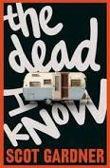
The Dead I Know by Scot Gardner, 2011
Aaron Rowe walks in his sleep and is haunted by dreams he can’t explain and memories he can’t recover. Death doesn’t scare him—his new job with a funeral director may even be his salvation. But if he doesn’t discover the truth about his hidden past soon, he may fall asleep one night and never wake up. In this dark and witty psychological drama about survival, Aaron finds that making peace with the dead may be easier than coming to terms with the living.

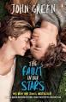
The Fault in our Stars by John Green, 2014
The story is narrated by Hazel Grace Lancaster, a 16-year-old girl with thyroid cancer that has affected her lungs. Hazel is forced by her parents to attend a support group where she subsequently meets and falls in love with 17-year-old Augustus Waters, an ex-basketball player and amputee. Though both know that life together for them will be short they learn to support one another and live what’s left of their time to the fullest.

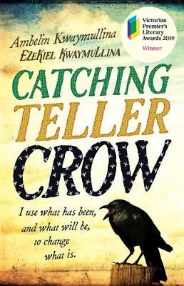
Catching Teller Crow by Ambelin Kwaymullina, Ezekiel Kwaymullina, 2018
Nothing’s been the same for Beth Teller since she died. Her dad, a detective, is the only one who can see and hear her - and he’s drowning in grief. But now they have a mystery to solve together. Who is Isobel Catching, and what’s her connection to the fire that killed a man? What happened to the people who haven’t been seen since the fire? As Beth unravels the mystery, she finds a shocking story lurking beneath the surface of a small town, and a friendship that lasts beyond one life and into another. Told in two unforgettable voices, this gripping novel interweaves themes of grief, colonial history, violence, love and family.

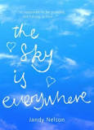
The Sky Is Everywhere by Jandy Nelson, 2010
Adrift after her sister Bailey's sudden death, Lennie finds herself torn between quiet, seductive Toby—Bailey's boyfriend who shares her grief—and Joe, the new boy in town who bursts with life and musical genius.
A beautiful, funny and heartfelt novel about grief, love and forgiveness.

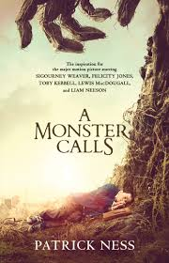
A Monster Calls by Patrick Ness, 2016
The story of Conor O'Malley, a 13-year-old boy who is dealing with his mother's illness. Her impending death hangs over the bulk of the book, and Conor must explore his own emotions through stories to find peace in her passing and how he feels about it.

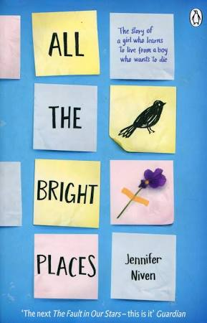
All the Bright Places by Jennifer Niven, 2015
Theodore Finch is fascinated by death, and he constantly thinks of ways he might kill himself. But each time, something good, no matter how small, stops him. Violet Markey lives for the future, counting the days until graduation, when she can escape her Indiana town and her aching grief in the wake of her sister's recent death.

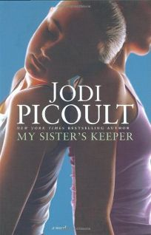
My Sister’s Keeper by Jodi Picoult, 2004
The story of thirteen-year-old Anna Fitzgerald, who sues her parents for medical emancipation when she discovers she was conceived specifically to donate a kidney to her elder sister Kate, who is gradually dying from acute leukaemia.

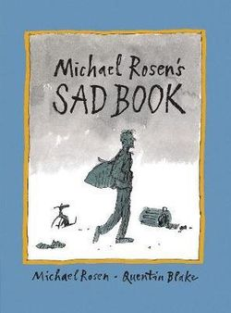
Michael Rosen’s Sad Book by Michael Rosen, Quentin Blake (Illustrator), 2010
A heartbreakingly honest account of a father's grief for his son from the illustrious pairing of two former Children's Laureates. It chronicles Michael's grief at the death of his son Eddie from meningitis at the age of 19. A moving combination of sincerity and simplicity, it acknowledges that sadness is not always avoidable or reasonable and perfects the art of making complicated feelings plain.

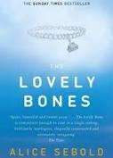
Lovely Bones by Alice Sebold, 2009
The story of Susie Salmon, a teenage girl who is raped and murdered in 1973. She goes to heaven and watches over her family as they cope with their loss. She also tries to give them clues so they can find her murderer—their next-door neighbour.

Taking Tom Murray Home by Tim Slee, 2019
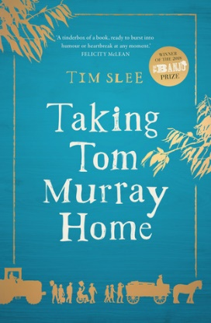
The winner of the inaugural Banjo Prize, this novel is a funny, moving, bittersweet Australian story of fires, families and the restorative power of community.
Bankrupt dairy farmer Tom Murray decides he'd rather sell off his herd and burn down his own house than hand them over to the bank. But something goes tragically wrong, and Tom dies in the blaze. His wife, Dawn, doesn't want him to have died for nothing and decides to hold a funeral procession for Tom as a protest, driving 350km from Yardley in country Victoria to bury him in Melbourne where he was born. To make a bigger impact she agrees with some neighbours to put his coffin on a horse and cart and take it slow - real slow.
But on the night of their departure, someone burns down the local bank. And as the motley funeral procession passes through Victoria, there are more mysterious arson attacks. Dawn has five days to get to Melbourne. Five days, five more towns, and a state ready to explode in flames...
A timely, thought-provoking, heart-warming, quintessentially Australian story about grief, pain, anger and loss, but also hope - and how community, friends and love trump pain and anger, every time.

The Goldfinch: A Novel (Pulitzer Prize for Fiction) by Donna Tartt , 2019

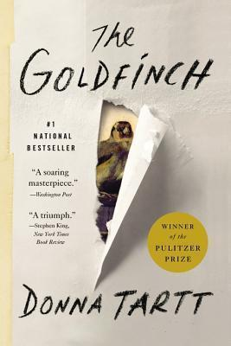
A young boy grieving his mother's death is pulled into a gritty underworld of art and wealth. Theo Decker, a 13-year-old New Yorker, miraculously survives an accident that kills his mother. Abandoned by his father, Theo is taken in by the family of a wealthy friend. Bewildered by his strange new home on Park Avenue, disturbed by schoolmates who don't know how to talk to him, and tormented above all by a longing for his mother, he clings to the one thing that reminds him of her: a small, mysteriously captivating painting that ultimately draws Theo into a wealthy and insular art community.
As an adult, Theo moves silkily between the drawing rooms of the rich and the dusty labyrinth of an antique store where he works. He is alienated and in love -- and at the centre of a narrowing, ever more dangerous circle.
The Goldfinch is a mesmerizing, old-fashioned story of loss and obsession, survival and self-invention. From the streets of New York to the dark corners of the art underworld, this "soaring masterpiece" examines the devastating impact of grief and the ruthless machinations of fate.

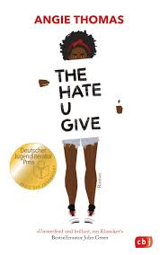
The Hate you Give by Angie Thomas, 2018
This crucial book was inspired by the Black Lives Matter movement, and follows Starr, the sole witness to her best friend Khalil's shooting death by a police officer. It explores not only the aftermath of the shooting, but delves into questions of grief, anxiety, legacy, identity, race relations, family dynamics, loyalty, and what it means to grow up in a black neighbourhood where gangs are sometimes the only way out of the cycle of poverty and hunger, and the police are usually more harmful than helpful.

The Grief Keeper by Alexandra Villasante, 2019
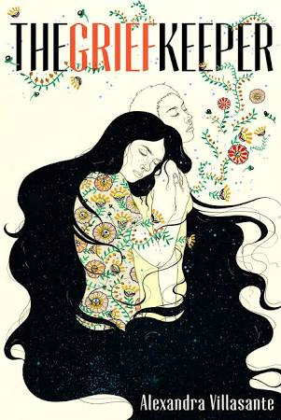
A timely and heartfelt speculative narrative about healing, faith, and freedom. Seventeen-year-old Marisol has always dreamed of being American, learning what Americans and the US are like from television and from Mrs. Rosen, an elderly expat who had employed Marisol's mother as a maid. When she pictured an American life for herself, she dreamed of a life like Aimee and Amber's, the title characters of her favourite American TV show. She never pictured fleeing her home in El Salvador under threat of death and stealing across the US border as "an illegal", but after her brother is murdered and her younger sister, Gabi's, life is also placed in equal jeopardy, she has no choice, especially because she knows everything is her fault. If she had never fallen for the charms of a beautiful girl named Liliana, Pablo might still be alive, her mother wouldn't be in hiding and she and Gabi wouldn't have been caught crossing the border. But they have been caught and their asylum request will most certainly be denied. With truly no options remaining, Marisol jumps at an unusual opportunity to stay in the United States. She's asked to become a grief keeper, taking the grief of another into her own body to save a life. It's a risky, experimental study, but if it means Marisol can keep her sister safe, she will risk anything. She just never imagined one of the risks would be falling in love, a love that may even be powerful enough to finally help her face her own crushing grief. The Grief Keeper is a tender tale that explores the heartbreak and consequences of when both love and human beings are branded illegal.

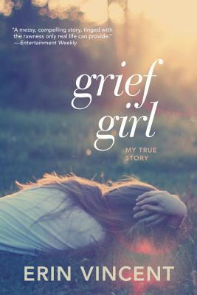
Grief Girl by Erin Vincent, 2008
It's just another October day until Erin's parents are hit by a speeding tow truck. Mom dies instantly. Dad dies one month later, after doctors assure Erin he's going to make it. Now Erin and her sister are left to raise their baby brother--and each other. This is Erin Vincent's gripping true story of how one moment tears a family apart and how love and strength come together to rebuild what was lost. Grief Girl will break your heart and then fill you with hope, time and time again.

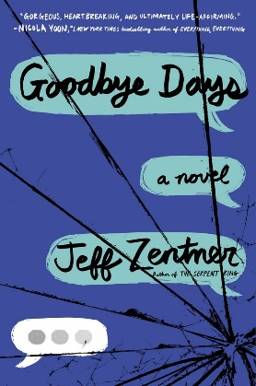
Goodbye Days by Jeff Zentner, 2017
Follows the grieving process of Carver Briggs, who sent a text message that may have caused the car accident that killed his three best friends. Now Carver can’t stop blaming himself for the accident and even worse, there could be a criminal investigation into the deaths. Then Blake’s grandmother asks Carver to remember her grandson with a ‘goodbye day’ together. Carver starts to help the families of his lost friends grieve with their own memorial days, along with Eli’s bereaved girlfriend, Jesmyn. But not everyone is willing to forgive. Carver’s own despair and guilt threatens to pull him under into panic and anxiety as he faces punishment for his terrible mistake. Can the goodbye days really help? Or has one text message destroyed his life forever?

Book Thief by Markus Zusak,
A story narrated by a compassionate Death who tells us about Liesel, a girl growing up in Germany during World War II. She steals books, learns to read, and finds comfort in words. She and Max, the young Jewish man her family protects, are the only main characters that survive the war.

Created by Dajo Finlayson, 2019

© Book Links (Qld) Inc 2019

