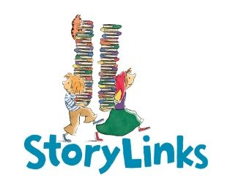
Review Questions for Junior Reviewers

1. Title of book

2. Author/Illustrator

3. Who is your favourite character? Describe them and tell us why you like them.

4. What was the most interesting/exciting/suspenseful moment in the story?

5. Did this story make you laugh/cry/ throw it across the room?

6. Would you have changed anything in the story and why?

7. To whom would you recommend this book?

8. Optional Is there anything else you want to say about this book?

9. How many hearts out of five?

♥ = Didn’t finish it
♥ ♥ = Ok, but not for me
♥ ♥ ♥ = I enjoyed this
♥ ♥ ♥ ♥ A great book, I recommend it
♥ ♥ ♥ ♥ ♥ One of the best books I have ever read!

Thankyou for being a StoryLinks Junior Reviewer
Name:
Age:
Interesting Fact about yourself:

