Poetry for Children of all ages
It is in poetry that the child discovers the possibilities of language – its range, its flexibility, its infinite variety, and these anthologies provide a broad range of the poetry experience. Here is a sample of poetry from a diverse selection of contemporary and historical poets, covering a broad range of topics - from personal subjects like emotions and family, to the wonders of the natural environment
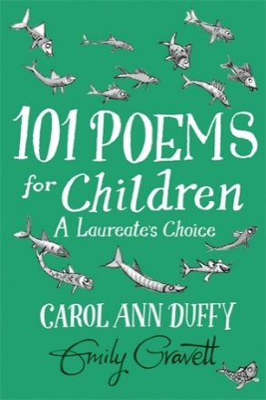
101 Poems for Children A Laureate’s Choice Selected by Carol Ann Duffy, illustrated by Emily Gravett 2012
A stunning collection of classic and modern verse chosen by the 2009-2019 British Poet Laureate, Carol Ann Duffy. Full of gorgeous black and white artwork from the multi-award-winning illustrator Emily Gravett, this book is a delight for children of all ages and is a pleasure to read aloud for everyone in the family.
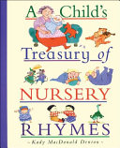
A Child’s Treasury of Nursery Rhymes Selected and illustrated by Kady MacDonald Denton 2004
Nursery rhymes have been well-loved for generations because they comfort, entertain and delight children. This collection captures the joy and magic of childhood. Denton’s charming illustrations and thoughtful selection of 145 favourites will appeal to children at different stages in their lives.
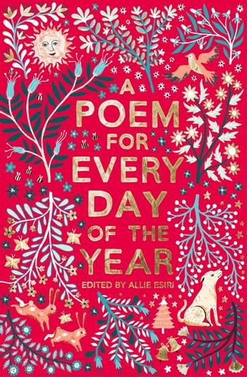
A Poem for Every Day of the Year Selected by Allie Esiri, illustrated by Zanna Goldhawk 2017
A magnificent collection of 366 poems, one to share on every day of the year. Reflecting the changing seasons and linking to events on key dates – funny for April Fool's Day, festive for Christmas – these poems are thoughtful, inspiring, humbling, informative, quiet, loud, small, epic, peaceful, energetic, upbeat, motivating, and empowering! A Poem for Every Night of the Year selected by Allie Esiri, is a companion volume.
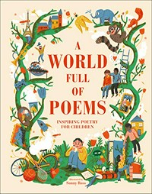
A World Full of Poems Selected by Sylvia M Vardell, illustrated by Sonny Ross 2020
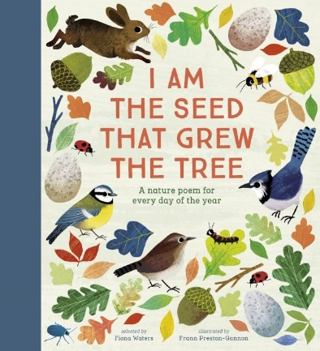
A gorgeously illustrated introduction to poetry for children, featuring poems about everything from science, sports, and space, to friendship, family, and feelings. This thoughtfully crafted anthology is perfect for children new to verse and for young poetry fans seeking out new favourites. Poems are complemented by detailed illustrations, timelines, and interesting facts about the topics covered. Prompts and activities inspire children to create their own poetry, and devices like rhyme, repetition, and alliteration are introduced and explained in a fun and accessible manner.
I Am The Seed That Grew The Tree A nature poem for every day of the year Selected by Fiona Waters, illustrated by Frann Preston-Gannon 2018
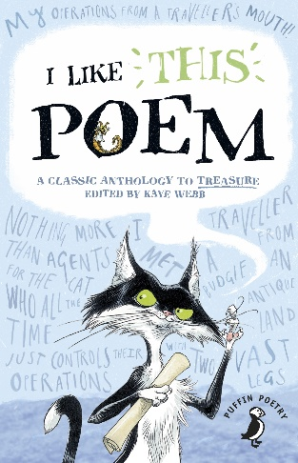
Named after the first line of Judith Nicholls’ poem ‘Windsong’, this contains 366 nature poems – one for every day of the year, including leap years. Filled with familiar favourites and new discoveries, written by a wide variety of poets. Here are poems to share at the beginning of the day, or at bedtime, or just to dip into whenever you might like.
I Like This Poem Edited by Kaye Webb 2016
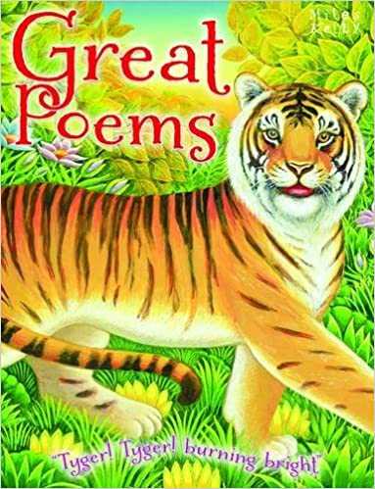
Highwaymen and naughty children, sharks, and baboons, the Snitterjipe and the Jabberwocky, all have their part to play. Each and every poem in this treasure chest of family favourites was chosen by a child for other children. With poems from William Wordsworth and Christina Rosetti to Roald Dahl and Michael Rosen, there really is something for everyone. Classics to savour and new favourites to discover!
Great Poems by Miles Kelly Publishing 2014
In this lavishly illustrated book there are over 300 poems to be found in sections such as Love, Children's Poems, Wit and Humour, Food and Drink and Animals. Some great poets are represented here, like William Shakespeare and John Donne, Walt Whitman and Emily Dickinson, Christina Rossetti, and John Keats. Each poem has an information box with biographical details about the poet providing historical and literary context.

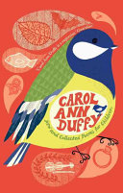
New and Collected Poems for Children by Carol Ann Duffy, illustrated by Alice Stevenson 2009
Carol Ann Duffy's writing for younger readers has always bubbled with wit and humour, intelligence, and affection, and introduced us to many strange and wonderful characters along the way. Among the enchanting voices to be heard are those of the Loch Ness Monster's husband, the oldest girl in the world and a herd of cows on a shopping trip to Manchester.
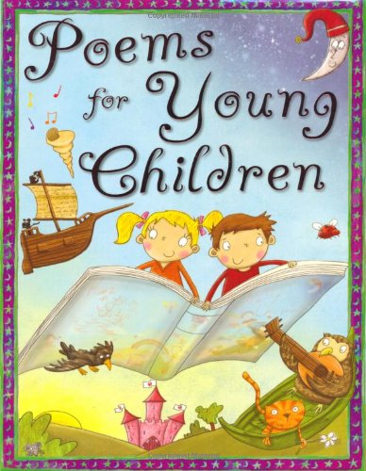
Poems for Young Children Compiled by Tig Thomas 2010
A rich collection profusely illustrated in a wide variety of styles. It contains popular favourites as well as some not so familiar arranged under various headings: Enchanted Lands, All the Day Long, A Wonderful World, and Fun and Nonsense. An excellent resource for the classroom and a boon for parents.
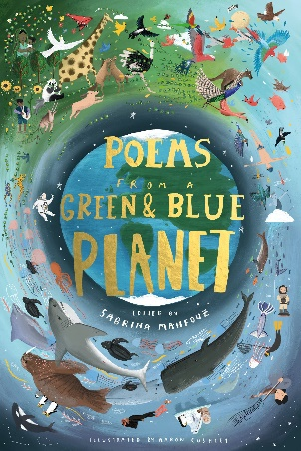
Poems from a Green & Blue Planet Edited by Sabrina Mahfouz 2019
This stunning collection of new and classic poems from around the world celebrates the diversity of life on our green and blue planet, to be shared with all the family. With new poems from Raymond Antrobus, Mona Arshi, Kate Tempest, Hollie McNish, Dean Atta, Sabrina Mahfouz and more. Explore all the worlds that make up our world, and hear the voices, past and present, that sing out from it. From haikus to sonnets, from rap to the Romantics, this joyous collection celebrates life in all corners of our beautiful planet.
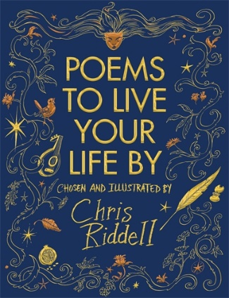
Poems to Live Your Life By Chosen and illustrated by Chris Riddell 2018
This gorgeously illustrated collection includes forty-six poems and is divided into sections covering: musings, youth, family, love, imaginings, nature, war, and endings. It includes poems from William Shakespeare, Lewis Carroll, Nick Cave, Leonard Cohen, Carol Ann Duffy, and Christina Rossetti sitting alongside Neil Gaiman, Roger McGough and W. B. Yeats.

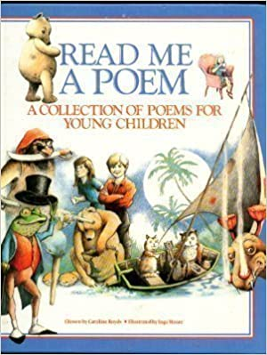
Read Me a Poem A collection of poems for young children Chosen by Caroline Royds, illustrated by Inga Moore 1986
For those looking for more traditional poems and verse, this imaginatively illustrated collection includes works by Carl Sandburg, Robert Frost, Sylvia Plath and Robert Louis Stevenson and quite a few by Anon. Includes many poems that have been favourites for generations of children.
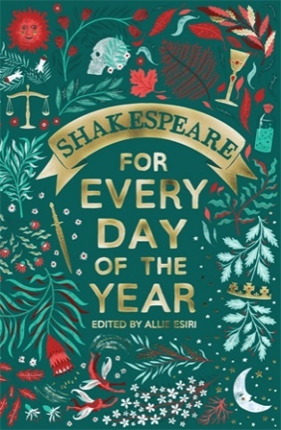
Shakespeare for Every Day of the Year Edited by Allie Esiri 2019
Each page contains an extract, which might be a famous poem, quote, or scene, matched to the date. Allie Esiri's introductions give her readers a new window into the work, time, and life of the greatest writer in the English language. Perfect for reading or sharing, this book brings you Shakespeare’s best-known and best-loved classics alongside lesser known extracts combined with Esiri’s entertaining and insightful thoughts on each entry.
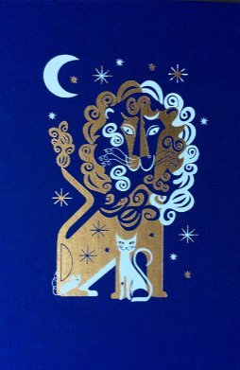
The Folio Book of Children’s Poetry Introduced by Penelope Lively, illustrated by Lesley Barnes 2018
An eclectic and thought-provoking collection chosen to amuse, entertain and challenge young readers – from classic Wordsworth to the inimitable Dahl. The 88 poems in this anthology have been carefully selected to introduce younger readers to the infinite possibilities of language through a broad range of themes, all beautifully illustrated.
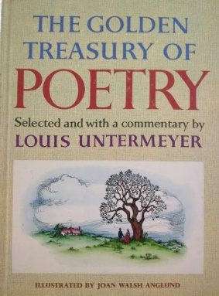
The Golden Treasury of Poetry Selected and with a commentary by Louis Untermeyer, illustrated by Joan Walsh Anglund 1961
A famous collection of verse worth trying to find. " In these pages are poems that will become favourites; you will never lose your taste for them. Some of them will be exciting new experiences; some will let you see familiar things as though you had never seen them before. But all of them were meant primarily to be enjoyed. Poetry is written in many moods and on many levels, each of which provides its own particular pleasure. Come along through these pages and let me show you what I mean." --Louis Untermeyer.
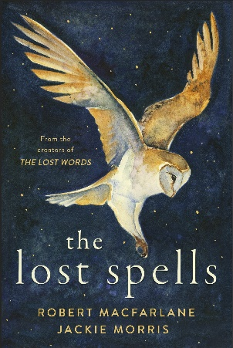
The Lost Spells By Robert Macfarlane and Jackie Morris 2020
The sequel to The Lost Words but new in form, The Lost Spells is a pocket-sized treasure, a new collection of 'spells' - acrostic poetry and artwork written to be read aloud, calling to forest, field, riverbank, ocean, and also to the heart. These 'spells' summon back what is often lost from sight and care and inspire protection and action on behalf of the natural world. From Jay to Jackdaw, Oak to Barn Owl, Silver Birch to Grey Seal, they capture the special, individual spirit of each plant and creature.
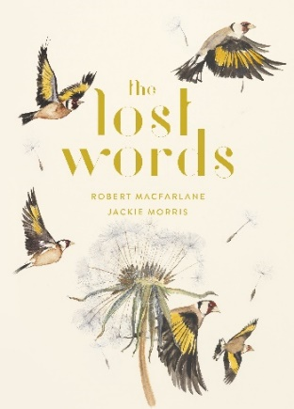
The Lost Words A spell book by Robert Macfarlane and Jackie Morris 2017
Words are disappearing from children's lives. Words like Dandelion, Otter, Bramble, Acorn and Lark which represent the natural world of childhood, a rich landscape of discovery and imagination that is fading from children's minds. The Lost Words stands against the disappearance of wild childhood. It is a joyful celebration of the poetry of nature words and the living glory of a distinctive, British countryside. With acrostic spell-poems and hand-painted illustrations this enchanting book captures the irreplaceable magic of language and nature for all ages.
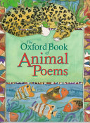
The Oxford Book of Animal Poems By Michael Harrison and Christopher Stuart-Clark 1996
An anthology that combines the finest of verse with a survey of wildlife and human cultures of the earth. It begins with the oceans--whales, dolphins, sharks--and then circles the world, pausing to visit a host of animals who delight in their strengths, but are often all too aware of the fragility of the future. Poets from each continent are represented and each reveals much about the human culture as well as the animals of their lands.
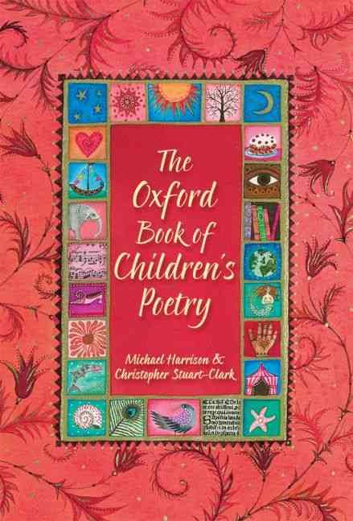
The Oxford Book of Children’s Poetry By Michael Harrison and Christopher Stuart-Clark 2007
To coincide with the centenary of Oxford Children's Books this definitive new collection includes all the major children's poets. With a wonderful range of both classic and modern favourites, this is a book that will be treasured for a lifetime. The poems are enhanced with black and white artwork from a number of top children's illustrators.
The Oxford Book of Poetry for Children Compiled by Edward Blishen, illustrated by Brian Wildsmith 1963
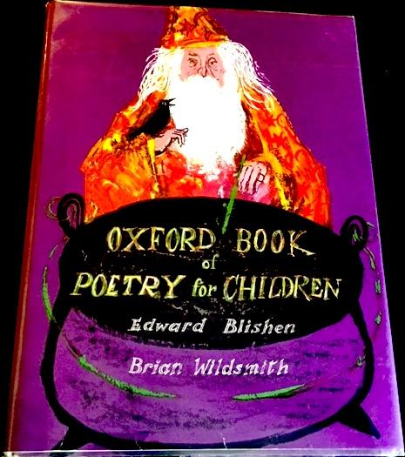
Inspire young children to move from nursery rhymes to serious (but not solemn!) verse with this burgeoning collection that includes poems by Lewis Carroll, Christina Rossetti, Shakespeare, and many others. The illustrations reflect the vitality of the verses. Edward Blishen, who compiled the anthology, was a teacher for 15 years, and the volume has been spectacularly illustrated by Brian Wildsmith. Worth hunting for.
The Rattle Bag Selected by Seamus Heaney and Ted Hughes 1982
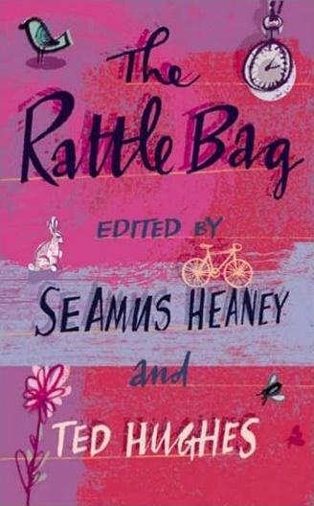
This anthology of poetry (mostly in English but occasionally in translation) is for general readers and students of all ages and backgrounds. These poems are the personal favourites of the editors, themselves two of contemporary literature's leading poets. Heaney and Hughes have elected to list their favourites not by theme or by author but simply by title (or by first line, when no title is given). "We hope that our decision to impose an arbitrary alphabetical order allows the contents to discover themselves as we ourselves gradually discovered them--each poem full of its singular appeal, transmitting its own signals, taking its chances in a big, voluble world."
This is Home: Essential Australian Poems for Children Edited by Jackie French illustrated by Tania McCartney 2019
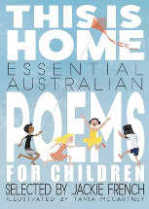
Ideal for sharing with the whole family, this extensively illustrated edition brings together old favourites and sure-to-be new favourites in an indispensable addition to children's bookshelves. From poems that whisper to poems that roar, from words of tranquillity and heartbreak to those of the witty and absurd, there is something within these pages to make everyone feel at home.
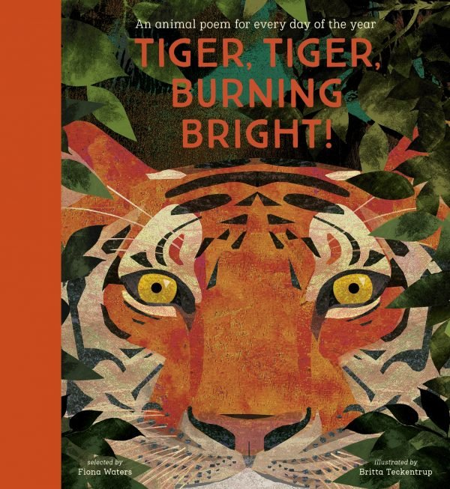
Tiger, Tiger, Burning Bright! Selected by Fiona Waters illustrated by Britta Teckentrup 2020
This lavishly illustrated treasury of 366 animal poems – one for every day of the year – ranges from unforgettable classics to contemporary works from around the world, including poetry in translation. The poems include work by Roger McGough, William Blake, Dick King-Smith, Ted Hughes, Grace Nichols, Lewis Carroll, Christina Rossetti, Emily Dickinson. Britta Teckentrup’s breathtaking illustrations bring together all the richness and wonder of the animal kingdom.

Compiled by Mia Macrossan

©StoryLinks 2021

